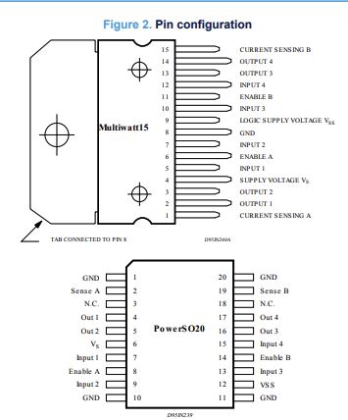

The L298N motor driver is a dual H-bridge motor driver that can control two DC motors independently.

### **Power Pins:**

* **Vcc (Pin 4)**: This is the power input pin for the motors. You connect the external power source (in your case, a 6V battery) to this pin to provide power to the motors.
* **GND (Pins 5, 8)**: Ground pins that must be connected to the ground of both the power supply (battery) and the control circuit (microcontroller, such as your ESP32). Ensuring common ground is crucial for proper operation.
* **5V (Pin 9)**: This pin provides a regulated 5V output from the motor driver, which can be used to power a microcontroller (if the L298N is powered by a higher voltage than 5V). **Note**: If you are using a low voltage like 6V, you may not get 5V out of this pin reliably.

### **Motor Control Pins:**

* **IN1 (Pin 1)** and **IN2 (Pin 2)**: These are input pins used to control Motor 1. By applying either HIGH or LOW signals, you control the direction of the motor. Here’s how these work:
  + **IN1 = HIGH**, **IN2 = LOW** → Motor rotates in one direction.
  + **IN1 = LOW**, **IN2 = HIGH** → Motor rotates in the opposite direction.
  + **Both LOW or HIGH** → Motor stops.
* **IN3 (Pin 3)** and **IN4 (Pin 6)**: These are input pins for Motor 2. They work in the same way as IN1 and IN2, controlling the direction of Motor 2.

### **Motor Output Pins:**

* **OUT1 (Pin 13)** and **OUT2 (Pin 14)**: These are the output pins connected to Motor 1. The motor is powered based on the signals sent to IN1 and IN2.
* **OUT3 (Pin 11)** and **OUT4 (Pin 12)**: These are the output pins for Motor 2, connected similarly to IN3 and IN4.

### **Enable Pins:**

* **Enable A (Pin 7)**: This pin controls whether Motor 1 is enabled. If connected to HIGH (5V), Motor 1 is active and responds to inputs on IN1 and IN2. If connected to a PWM signal, it allows you to control the speed of Motor 1.
* **Enable B (Pin 10)**: This pin controls whether Motor 2 is enabled. Similar to Enable A, connecting this pin to HIGH (5V) will activate Motor 2, and connecting it to a PWM signal will control Motor 2’s speed.

### **Additional Pins:**

* **Current Sense A (Pin 1)** and **Current Sense B (Pin 15)**: These pins are used for monitoring the current drawn by each motor. You typically connect them to ground unless you're using them with additional circuitry to monitor motor current.

### **Summary of Key Connections:**

* **Motor 1**: Controlled by IN1, IN2 (direction) and enabled by Enable A (speed control).
* **Motor 2**: Controlled by IN3, IN4 (direction) and enabled by Enable B (speed control).
* **Power**: Vcc connects to your battery (6V in your case), and GND connects to the negative terminal of the battery and the microcontroller's ground.